

**9th Annual Coach CJ Celebration!**

**Salute to Mardi Gras • Saturday, March 1, 2025**

**4 PM – 7 PM**

**NEW**

**TIME**

**Annandale Volunteer Fire Department Social Hall,**

**7128 Columbia Pike, Annandale, VA 22003**

**Come to celebrate a fundraiser in support of the Team Joyner Foundation for the Clayton Joyner Memorial Scholarships! Enjoy music, dancing, silent auction, games, food, & drinks for all ages!**

The Team Joyner Foundation is a 501(c) (3) tax exempt nonprofit organization.

Contributions are tax deductible to the extent provided by law. Tax Exempt #: 47-3737973

<https://www.teamjoynerfoundation.org/>

**9th Annual Coach CJ Celebration Registration Form**

**Name** _______________________________________________________________________________

**Email** ____________________________________ **Telephone** _______________________

Adult (21 & over) $25 ____ Family Rate $100 ____

Under 21 $15 ____ Sponsor $250 ____ Reach for the Wall $1,000 ____

Unable to attend but would like to make a donation: $ ____

I will be making my donation by:

Check Cash Zelle [teamjoynerfoundation@gmail.com](mailto:teamjoynerfoundation@gmail.com)

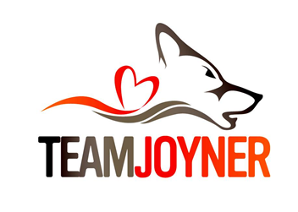

**Make checks payable to:** Team Joyner Foundation

**Mail checks to:** Team Joyner Foundation

P.O. Box 2614

Merrifield, VA 22116-2614