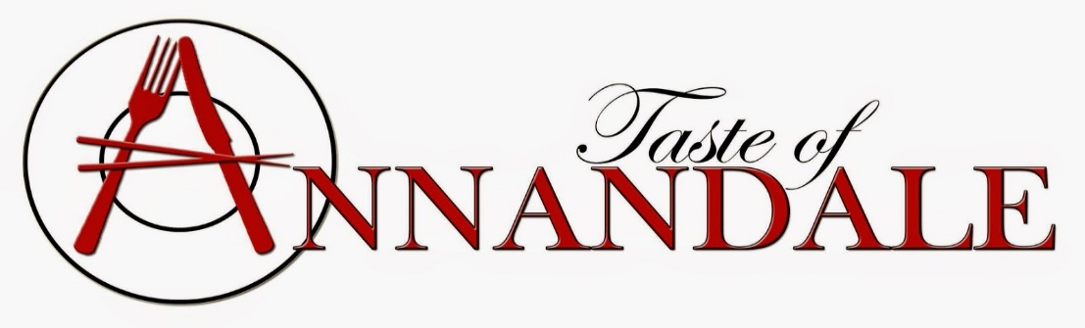
Official VIETNAMESE SANDWICH EATING CONTEST
Rules and Entry Form
Name: _______________________________________________________________
Address: _______________________________________________________________
Cell Phone: _______________________________________________________________
Email: _______________________________________________________________
*Age: ________________________________
- Must be 18 to participate.
- Must provide copy of driver’s license ID or student ID with entry form
Do you have any allergies? Please circle Yes or No
Do you have any health concerns that would prevent you from participating in the Vietnamese Sandwich BANH MI Eating Contest? Please circle Yes or No
CERTIFICATION AND SIGNATURE:
I certify that the information provided is correct and that I have carefully read, understand and accept the term of the Vietnamese Sandwich Eating Contest and the Official Contest Rules and Entry Form. As additional completion in this contest, my signature indicates my understanding and assumption of the risks, agreement with waiver of liability, and my voluntary participation in this contest.

Signature: ___________________________ Date: ___________________________

